OSI MODEL
The open system interconnection model is a layered framework. It has seven separate but interrelated layers. Each layer having unique responsibilities.


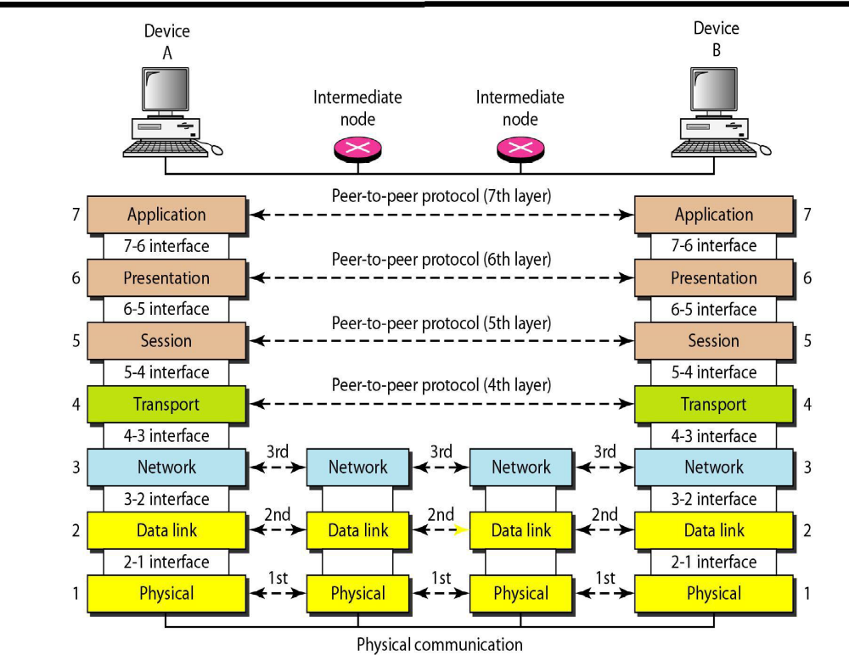

The figure shown below shows the layers involved when a message sent from A to B pass through
some intermediate devices.
- Both the devices A and B are formed by the framed architecture. And the intermediate nodes only having the layers are physical, Data link and network. In every device each layer gets the services from the layer just below to it. When the device is connected to some other device the layer of one device communicates with the corresponding layer of another device. This is known as peer to peer process.
- Each layer in the sender adds its own information to the message. This information is known is header and trailers. When the information added at the beginning of the data is known as header. Whereas added at the end then it called as trailer. Headers added at layers 2, 3, 4, 5, 6. Trailer added at layer 2.
- Each layer is connected with the next layer by using interfaces. Each interface defines what information and services a layer must provide for the layer above it.

FUNCTIONS OF THE LAYERS
PHYSICAL LAYER
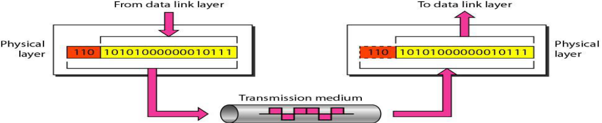
It coordinates the functions required to carry a bit stream over a physical medium. Encoding to be transmitted, bits must be encoded into signals, electrical or optical. Data rate it defines the transmission rate (number of bits sent per second).
Physical topology It defines how devices are connected (mesh, star, ring, bus or hybrid) Transmission mode Defines the direction of transmission between two devices: simplex, half-duplex, or full-duplex
The physical layer coordinates the functions required to transmit a bit stream over a physical medium. It deals with the mechanical and electrical specifications of the interface and the transmission medium.
The functions are,
1. Physical Characteristics of Interfaces and Media:
2. Representation of Bits
3. Data Rate
4. Synchronization of Bits
5. Line Configuration
6. Physical Topology
7. Transmission Mode

DATALINK LAYER

Datalink layer responsible for node-to-node delivery.
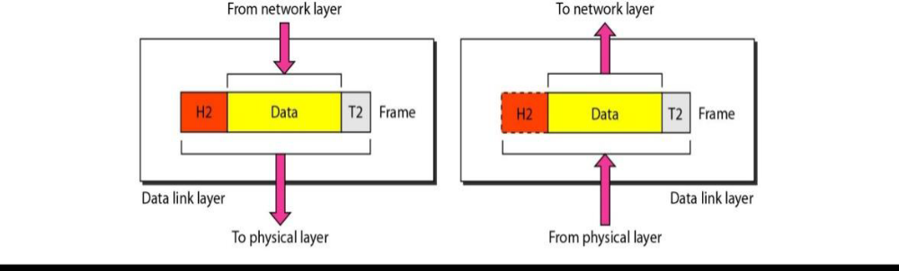
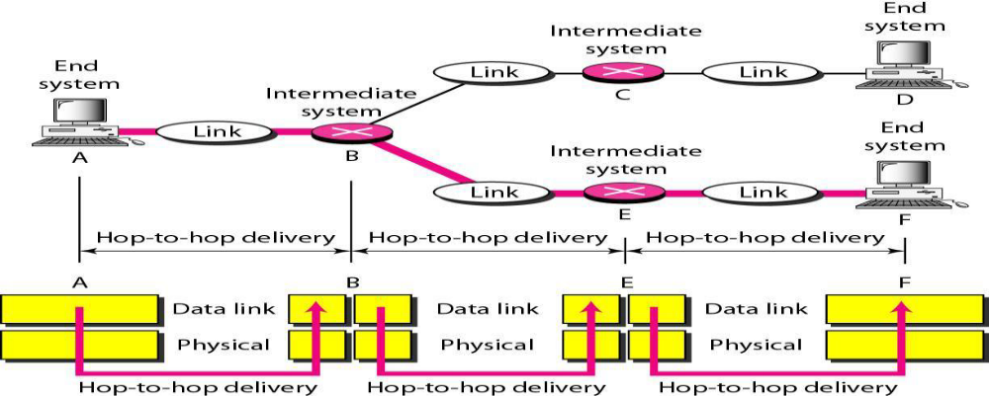

The data link layer transforms a raw transmission facility to a reliable link.
Framing:The bit stream is divided into manageable data units called frames.
Physical addressing:Header contains physical address of sender and receiver
Flow control:If receiving rate is less than the transmission rate, flow control mechanism avoids sender overwhelming the receiver.
Error control: Redundant information is put as tailor to detect and retransmit damaged/lostframes and to recognize duplicate frames.
Access control: When two or more devices are connected to the same link, link layerprotocols determines which device has control over the link at any given time.

Network Layer
When the sender is in one network and the receiver is in some other network then the network layer has the responsibility for the source to destination delivery.
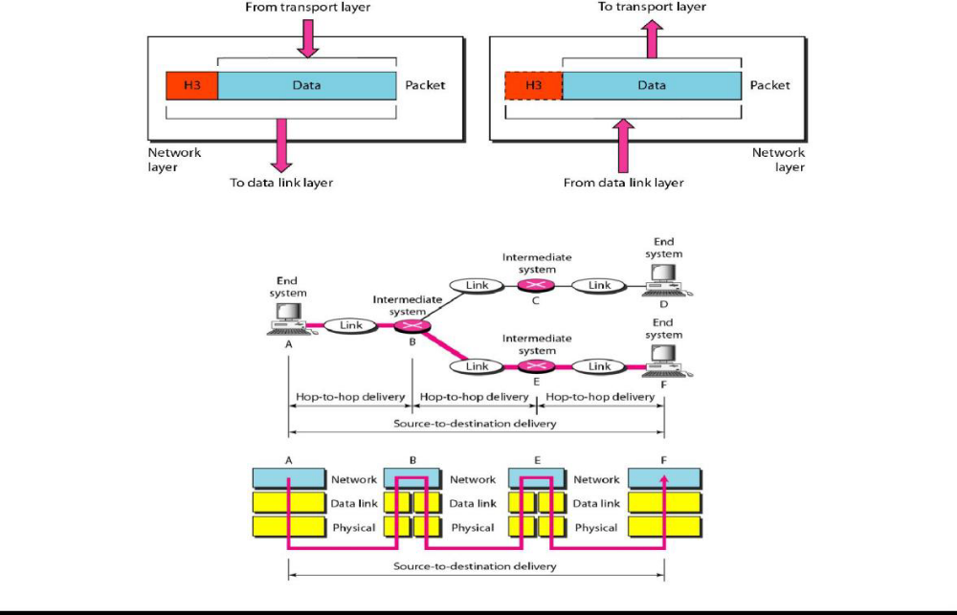

It is responsible for source-to-destination delivery of a data unit called packet.Logical addressing:A packet is identified across the network using logical addressing system provided by network layer and is used to identify the end systems. Routing:Routers preparerouting table to send packets to their destination.

Transport Layer

Transport layer is responsible for process-to-process delivery of the entire message.
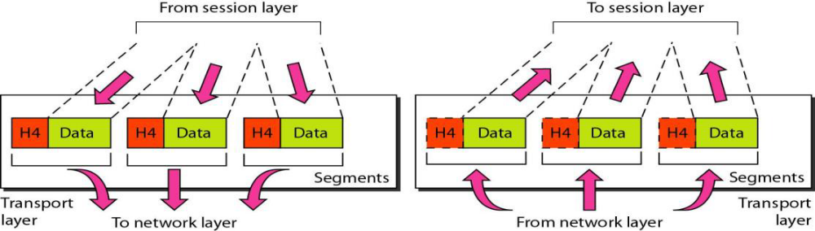

Port addressing: It includes a service-point or port address so that a process from one computer communicates to a specific process on the other computer.
Segmentation and reassembly: A message is divided into transmittable segments, each containing a sequence number. These numbers enable the transport layer to reassemble the message correctly at the destination and to identify which were lost / corrupted.
Connection control: Protocols can be either connectionless or connection-oriented.
Session Layer

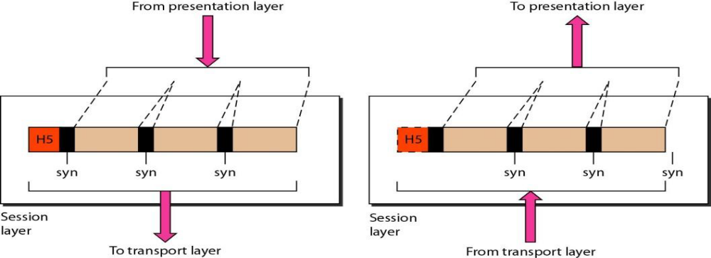
It establishes, maintains, and synchronizes interaction among communicating systems.

Presentation Layer
It is concerned with syntax and semantics of the information exchanged between peers.
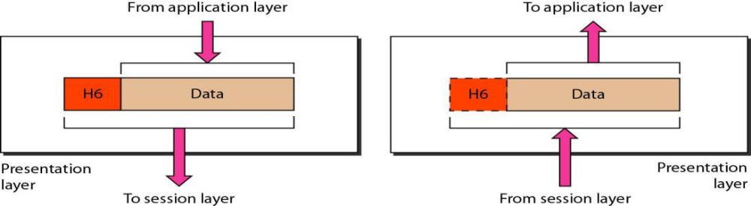
The responsibilities are,
1. Translation
2. Encryption
3. Compression
Translation: Because different computers use different encoding systems, the presentation layer is responsible for interoperability between these encoding methods.
Encryption: To carry sensitive information, a system ensures privacy by encrypting the message before sending and decrypting at the receiver end.
Compression: Data compression reduces the number of bits contained in the information. It is particularly important in multimedia transmission.
APPLICATION LAYER
The application layer enables the user to access the network. It provides interfaces between the users to the network.
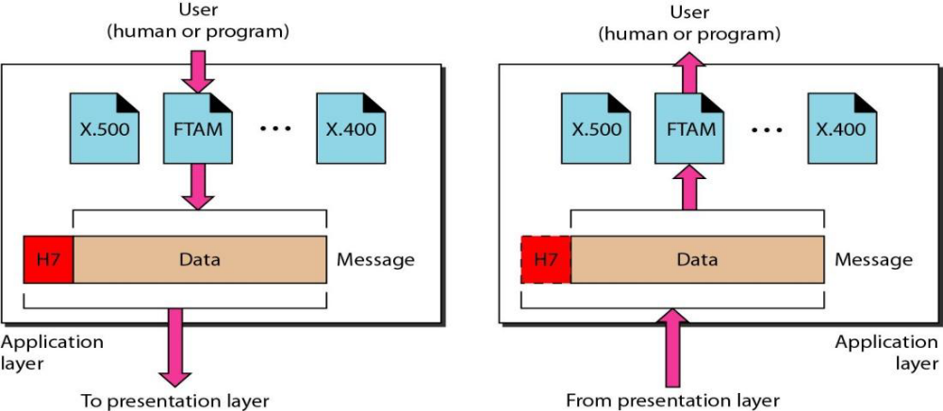
The responsibilities are,
1. Network Virtual Terminal
2. File Transfer, Access, and Management
3. Mail Services
4. Directory Services

